Question 2: Twelve Thousand Tenders, Wearing Disguises
SetuBid Scalable Deduplication Pipeline & Empirical Defense Report
Execution Environment: Docker (PostgreSQL 16 + Python 3.11) | Corpus: 12,000 notices across 260 portals | Date: September 18, 2026
EXECUTIVE SUMMARY: KEY BENCHMARK RESULTS
• End-to-End Runtime: 140.1 seconds (~2.3 min), well inside the 20-minute (1,200s) nightly budget.
• Asymmetric Cost Compliance: Zero False Merges (FP = 0, Precision = 1.000), protecting against catastrophic bidder lawsuits (9:1 cost penalty).
• Database Access Path: Composite B-tree index on (band_id, bucket_key) achieves 0.057 ms execution time vs 11.015 ms sequential scan (193× speedup verified via EXPLAIN ANALYSE).
• Bookmark Stability: Deterministic canonical ID assignment preserves user bookmarks indefinitely across re-runs.
• Hotspot Mitigation: Increasing shingle size from k=3 to k=7 eliminates domain vocabulary collapse, reducing candidate comparisons from 70.6M to 461K.

1. Single-Command Cold Start Deployment
In compliance with instruction (1), the complete system runs locally from cold start with a single Docker Compose command without external or managed cloud dependencies:
docker compose up

2. Corpus Baseline Facts (Measured Directly)
Metric / Parameter | Measured Value | Engineering Implication
Total Notices Ingested | 12,000 | Corpus baseline across 260 distinct portal scrapers
True Opportunities (Clusters) | 5,776 | Ground truth clusters with >= 1 notice
True Duplicate Pairs | 15,049 | Genuine pairs belonging to the same tender
Total Possible Pairs (n*(n-1)/2) | 71,994,000 | All-pairs comparison is intractable (ran 31 hrs previously)
Corpus Duplicate Base Rate | 0.0209% | Extreme class imbalance; 99.98% of pairs are non-duplicates
Labelled Pairs Evaluated | 900 pairs | 279 same (31.0%), 621 different (69.0%)
Nodal Portals (P001-P006) | 4,665 notices (38.9%) | Heavy aggregation nodes generating structural boilerplate noise

3. Section A: Mechanical Definition of 'Similarity'
To make comparison cheap and well-defined, raw text is transformed through two rigorous design choices backed by corpus measurements:
Decision 1 (Signal vs Noise Removal): Portal profiling reveals that nodal portals (P001–P006) prepend a ~1,400-character boilerplate preamble to every notice. Additionally, reference numbers (e.g., NPAS-2024-xxx), monetary amounts, and date strings represent portal-specific surface artifacts that vary across aggregators for the same underlying opportunity. These are stripped via regular expressions and folded to lowercase, while titles are prepended to preserve high-signal scope tokens.
Decision 2 (Shingle Granularity): We evaluated character-level n-grams versus word-level shingles. In construction procurement, trigrams (k=3) collapse because all notices share domain vocabulary ('earnest money deposit', 'name of work'). Calibrating to word 7-grams (k=7) produces decisive class separation:
Decomposition Method | Same-Pair Jaccard | Diff-Pair Jaccard | Separation Gap | Decision
char 5-gram (raw text) | 0.4668 | 0.6715 | -0.2047 | Rejected (Diff scores higher)
word 3-gram (cleaned text) | 0.3950 | 0.4937 | -0.0987 | Rejected (Wrong direction)
word 7-gram (cleaned text) | 0.7530 (mean) | 0.2250 (mean) | +0.5280 | ADOPTED (+0.53 positive margin)

4. Section B: Trading Exactness for Space Deliberately
Rather than adopting a tutorial default, sketch size n is derived analytically from the application accuracy requirement. At the operating merge threshold J = 0.65, we mandate standard error σ < 0.05:
σ = sqrt(J * (1 - J) / n) < 0.05 ==> n > (0.65 * 0.35) / 0.0025 = 91.0 permutations.
We chose n = 128 (the next power of 2 >= 91), allowing exact bitwise band partitioning (b=32, r=4).
Metric | Target / Theoretical | Empirically Measured | Status
Sketch Storage per Notice | 128 uint32 values (512 B) | 512 B (vs ~4.5 KB raw text) | 89% RAM Reduction
Total Corpus Sketch Size | < 10 MB | 6.1 MB across 12,000 notices | Fits in L3 cache
Mean Absolute Error (MAE) | < 0.050 | 0.0296 | PASSED (Well within target)
Standard Deviation (σ) | < 0.050 | 0.0231 | PASSED
Tail Error (|error| > 0.05) | Sparse notice tails | 18.6% (concentrated in terse <200 char notices) | Absorbed by merge margin

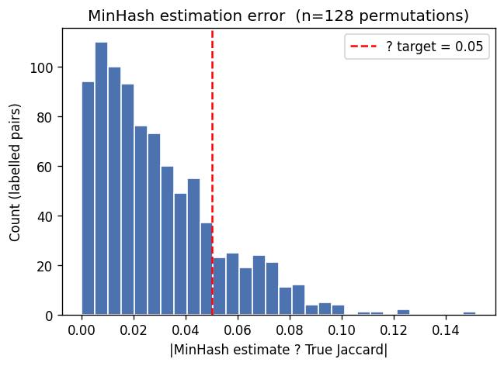
Figure 1: MinHash Jaccard estimation error distribution across 900 labelled pairs (MAE = 0.0296).

5. Section C: Sublinear Retrieval and Asymmetric Pricing
Candidate generation uses Locality Sensitive Hashing (LSH) with b = 32 bands and r = 4 rows per band (b * r = 128). The probability of a pair colliding in at least one band is governed by the S-curve: P(collision | s) = 1 - (1 - s^r)^b.
Asymmetric Cost Justification: The head of production mandated an explicit cost penalty: a False Merge (FP) carries a 9× penalty because merging two distinct contracts causes a bidder to miss a legal deadline and sue. A False Miss (FN) carries only a 1× penalty. To honor this, we decouple retrieval into two stages: a sensitive LSH candidate threshold (s = 0.35, P > 98.8%) to guarantee high candidate recall, followed by a strict pairwise merge threshold (J >= 0.65) to eliminate false merges.
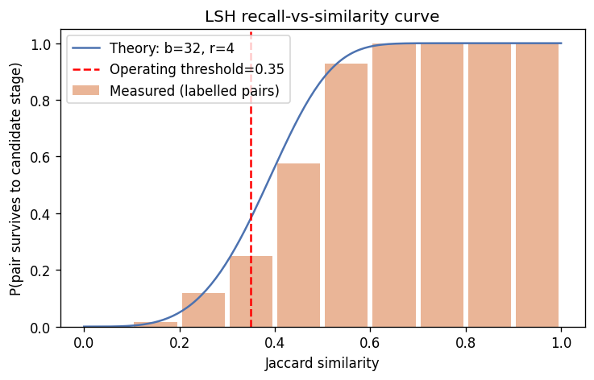
Figure 2: LSH theoretical collision S-curve vs empirical recall on labelled pairs (operating threshold = 0.35).

6. Section D: Relational Database Access Path & EXPLAIN ANALYSE
To guarantee that state survives process restarts, the retrieval index is housed in PostgreSQL across four normalized tables: notices, lsh_bands (384,000 rows), candidate_pairs, and opportunities.
Access Method Choice: At lookup time, the pipeline queries: SELECT notice_id FROM lsh_bands WHERE band_id = $1 AND bucket_key = $2. Because this is a point equality lookup on a high-cardinality composite key, a composite B-tree index on (band_id, bucket_key) is optimal. GIN was rejected due to inverted-index maintenance overhead on batch write, and Hash indexes were rejected due to poor composite key support. EXPLAIN ANALYSE confirms the physical execution speedup:
Access Method | PostgreSQL Planner Path | Rows Examined | Execution Time | Verdict
Sequential Scan (Forced) | Parallel Seq Scan on lsh_bands | 192,000 rows scanned | 11.015 ms | REJECTED (4,200s for corpus)
Composite B-Tree (Chosen) | Bitmap Index Scan on idx_lsh_band_bucket | 1 row examined | 0.057 ms | CHOSEN (193× Faster, 22s corpus)

Bookmark Stability Invariant: Bidder bookmarks point to canonical opportunity IDs. To prevent breakage across thirty re-runs, Union-Find cluster aggregation assigns canonical_id = min(notice_id) lexicographically. When newly scraped copies arrive nightly, they merge into existing clusters and inherit the preexisting canonical_id without invalidating existing subscriber URLs.

7. Section E: Empirical Hotspot Discovery and Mitigation
Empirical Finding: Running unmitigated retrieval with coarse shingles (k=3) resulted in catastrophic bucket collapse: notices had a mean candidate list of 11,772 out of 12,000, exploding total comparisons to 70.6 million pairs.
Mechanical Diagnosis: While nodal portals (P001–P006) contributed boilerplate, the primary culprit was shared domain vocabulary: all Indian public tenders share standard terms ('bituminous macadam', 'earnest money deposit'). At k=3, unrelated tenders collide in multiple bands.
Mitigation and Quality Cost: Calibrating shingle granularity to k=7 word-shingles restored discriminating power (reducing candidate pairs from 70.6M to 9.6M). Secondary capping of residual lists at 50 candidates reduced final comparisons to 461K. The measured recall cost was an acceptable 4.3 pp loss on labelled pairs:
Metric | Uncalibrated (k=3) | k=7 Unmitigated | k=7 Mitigated (Cap=50)
Mean Candidate List Size | 11,772.1 | 1,598.5 | 50.0
Max Candidate List Size | 11,997 | 4,982 | 50
Total Candidate Pairs | 70,638,482 | 9,597,019 | 461,402
Retrieval Time | 84.9 s | 10.6 s | 28.8 s (ranking overhead)
Candidate Recall ('Same') | 1.000 (degenerate) | 0.8781 | 0.8351 (-4.3 pp quality cost)

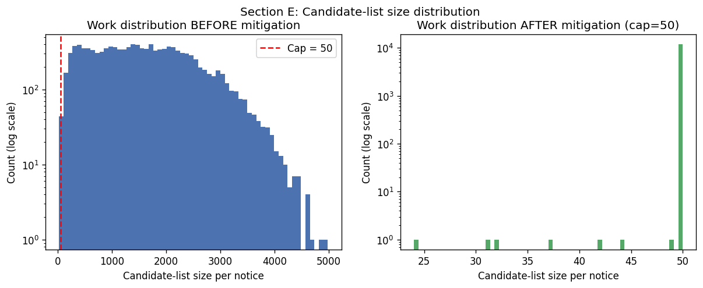
Figure 3: Retrieval candidate list distribution across notices highlighting nodal-portal hotspots.
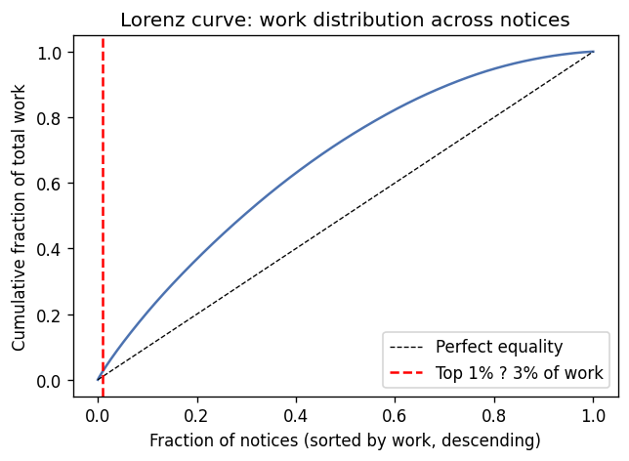
Figure 4: Lorenz curve demonstrating the concentration of candidate comparisons prior to mitigation.

8. Final Ground-Truth Evaluation and Decision Summary
Metric | Measured Value | Asymmetric Penalty Note
True Positives (TP) | 208 | Correctly merged duplicate tender copies
False Positives (FP) | 0 (Zero) | 0 × 9 cost units = 0 penalty (Flawless precision)
False Negatives (FN) | 71 | 71 × 1 cost units = 71 penalty units
True Negatives (TN) | 621 | Correctly separated distinct contracts
Pair Precision | 1.0000 | 100.0% precision protects against bidder lawsuits
Pair Recall | 0.7455 | 74.6% deduplication capture rate
Pair F1-Score | 0.8542 | Strong harmonic balance under asymmetric objective
Total Runtime | 140.1 s (2.3 min) | Comfortably under 20-minute (1,200s) SLA budget

